**1.1 Amino Acids Found in Proteins\***

A Note on Terminology

* Not every amino acid in the human body is specified by a codon in the genetic code or incorporated into proteins
* We will only focus on the 20 α-amino acids encoded by the human genetic code i.e. **proteinogenic amino acids**
  + α-carbon is the “central” carbon to which amino group and carboxyl group are bonded to

Stereochemistry of Amino Acids

* Except for glycine, all amino acids are chiral (or stereogenic) i.e 4 different groups
* Only threonine and isoleucine have a chiral carbon in their side chains
* All chiral eukaryotic amino acids are L
* Except for cysteine (R) , all chiral amino acids have an (S) configuration

Structures of the Amino Acids

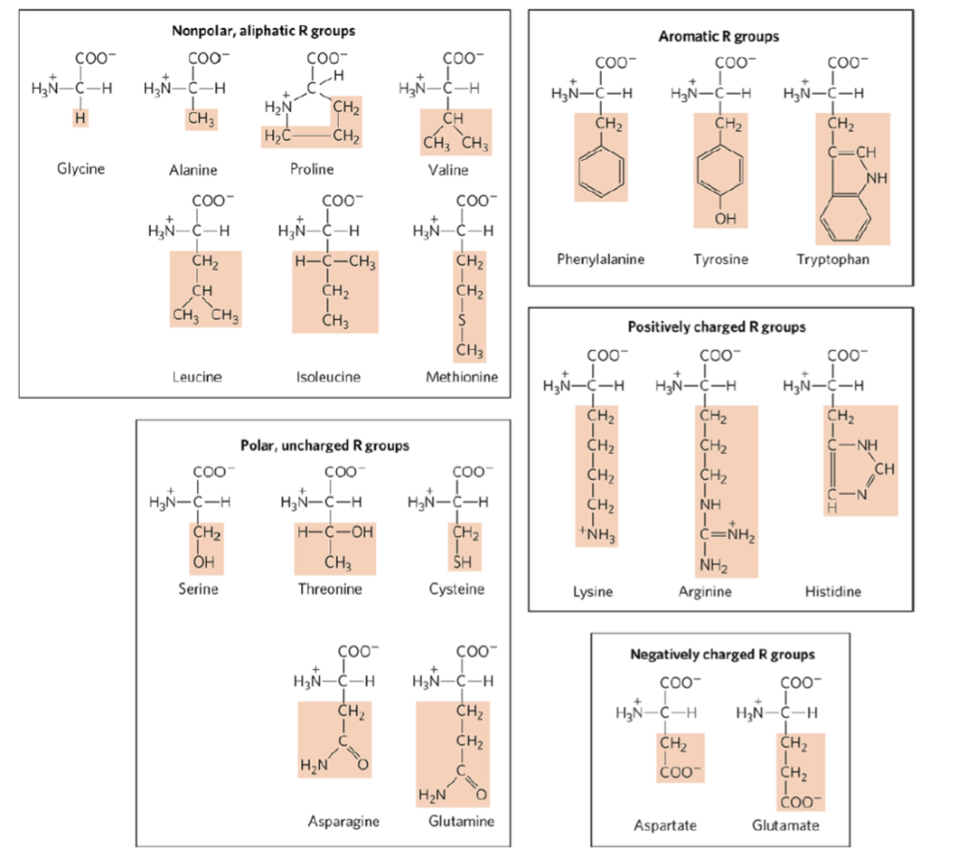

Amino Acid Abbreviations

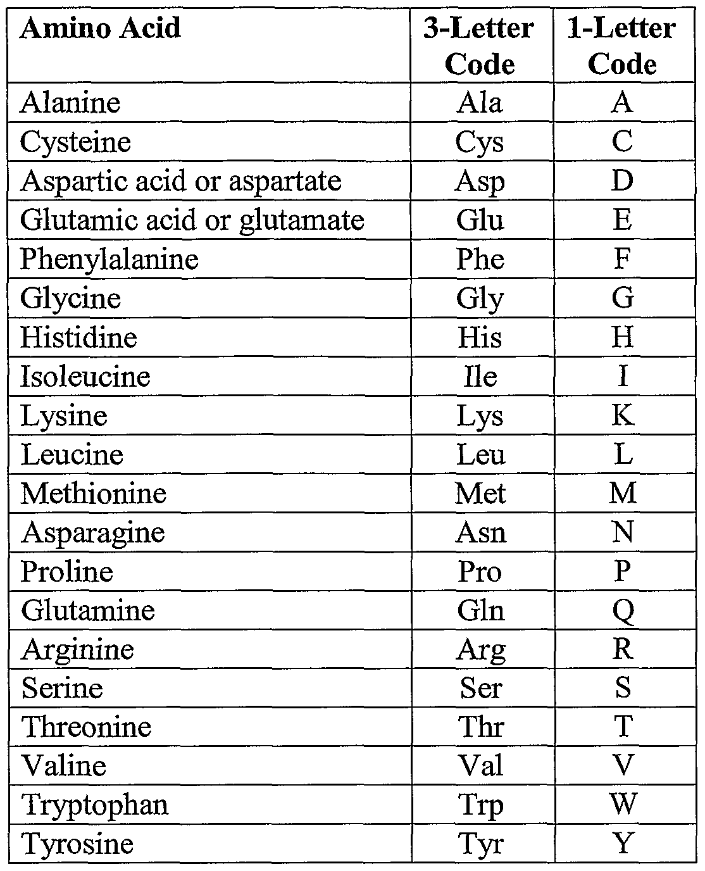

**1.2 Acid-Base Chemistry of Amino Acids**

Protonation and Deprotonation

* All amino acids have at least 2 groups that can be deprotonated → 2 pKa values
  + pKa1 ← carboxyl group (around 2)
  + pKa2 ← amino group (around 9-10)
* Amino acids with ionizable R group → at least 3 pKa values

1. If pH < pKa → protonation (more H+) → amino acid positively charged at **acidic** pH levels
2. If pH > pKa → deprotonation (more OH-) → amino acid negatively charged at **basic** pH levels
3. Intermediate pH → If positive and negative charges balance out → zwitterion

Titration of Amino Acids

* pI = **isoelectric point** (neutral charge)
* 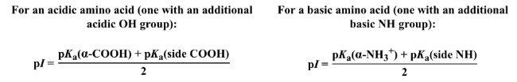
  + Take the average of the pKa of the groups that give the amino acid +1 and -1 charge (not +2 or -2!)

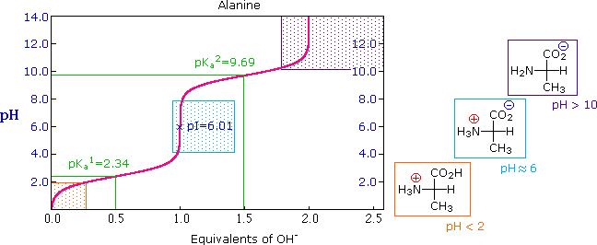

**1.3 Peptide Bond Formation and Hydrolysis\***

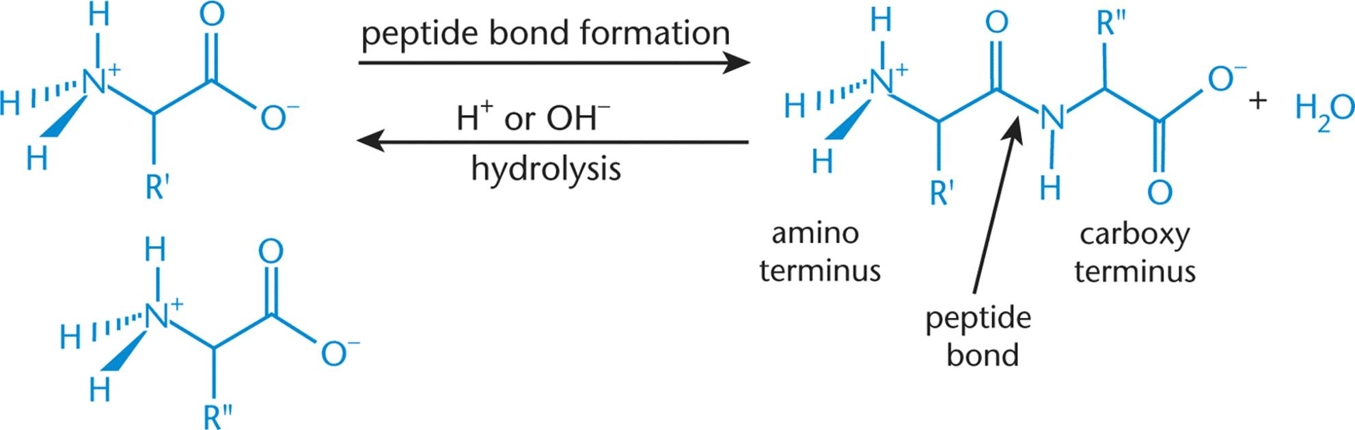

Peptide Bond Formation

* Electrophilic carbonyl carbon on first A.A is attacked by nucleophilic carbon on second A.A → hydroxyl group of the carboxylic acid is kicked off → peptide bond
* Amide groups have delocalizable pi electrons → resonance (partial double bond) → rigidity of protein backbone

Peptide Bond Hydrolysis

* In organic chemistry, amides can be hydrolyzed using acid or base catalysis
* In living organisms, hydrolysis is catalyzed by hydrolytic enzymes e.g. trypsin (only at specific sites)

**1.4 Primary and Secondary Protein Structure\***

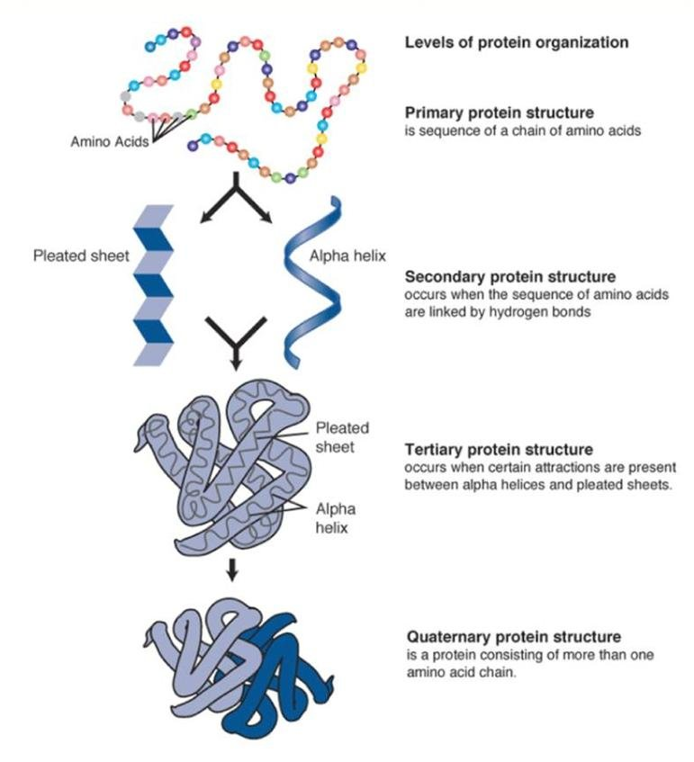

Primary Structure

* Stabilized by the formation of **covalent peptide bonds** between adjacent amino acids

Secondary Structure

* α-helices or β-pleated sheets
* Stabilized by the formation of intramolecular **hydrogen bonds** between different residues
* Proline has a rigid structure, hence will introduce:
  + a kink in the peptide chain of α-helices (rarely) → usually found at the start of an α-helix
  + a turn between the chains of β-pleated sheets

**1.5 Tertiary and Quaternary Protein Structure\***

Tertiary Structure

* 3D shape
* Stabilized by the formation of **hydrophilic and hydrophobic interactions**, **acid-base/salt bridges** and **disulfide bonds** between R groups of amino acids

Folding and Solvation Layer

* Move hydrophobic residues away from water molecules, and hydrophilic residues towards water molecules

Quaternary Structure

* Not all proteins have quaternary structure
* Only exist for proteins that contain **more than 1 polypeptide chain**
* Roles
  + Increase stability by reducing the surface area of the protein complex
  + Reduce the amount of DNA needed to encode the protein complex
  + Bring the catalytic sites close together → intermediates from one reaction can be shuttled to a second reaction
  + **Cooperativity (or allosteric effects)**

Conjugated Proteins

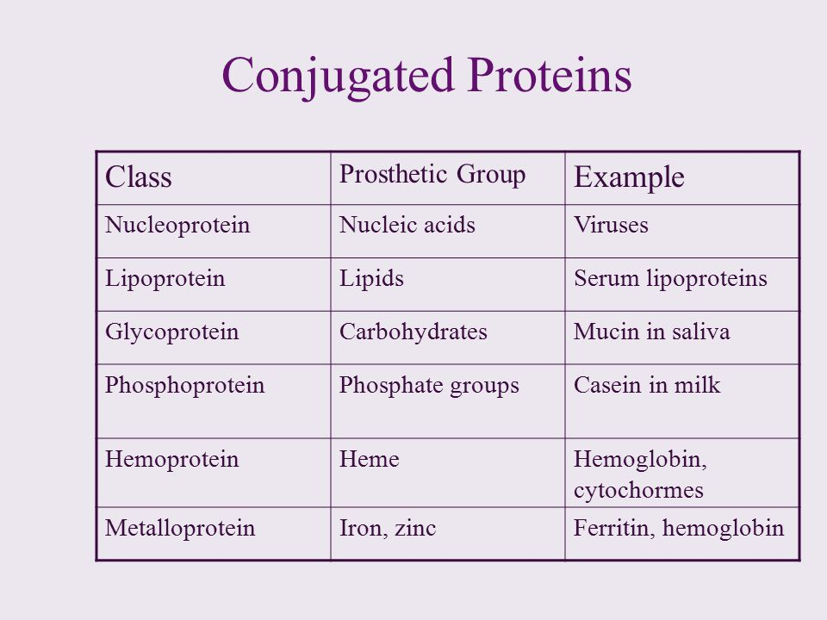

**1.6 Denaturation**

* Denaturation → the protein loses its 3D structure
* Can be reversible or irreversible
* Affected by:
  + Heat → increase average KE → disrupts hydrophobic interactions
  + Solutes e.g. SDS → disrupt elements of secondary, tertiary, and quaternary structure